# Cars per Capita (2) in Python

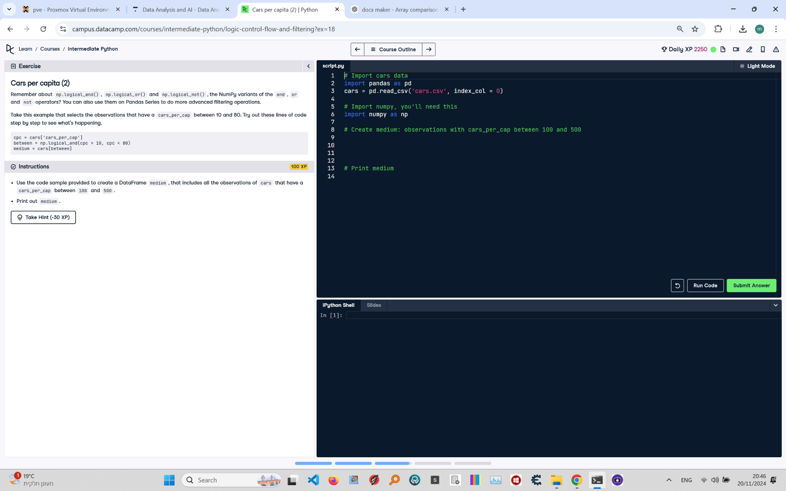

**Question:**

Remember about `np.logical_and()`, `np.logical_or()` and `np.logical_not()`, the NumPy variants of the `and`, `or`, and `not` operators? You can also use them on Pandas Series to do more advanced filtering operations.  
Use the code sample provided to create a DataFrame `medium`, that includes all the observations of `cars` that have a `cars_per_cap` between 100 and 500.  
Print out `medium`.

**Answer:**

Here is the Python code that solves the problem:

# Import cars data  
import pandas as pd  
import numpy as np  
  
# Read the dataset  
cars = pd.read_csv('cars.csv', index_col=0)  
  
# Create medium: observations with cars_per_cap between 100 and 500  
between = np.logical_and(cars['cars_per_cap'] > 100, cars['cars_per_cap'] < 500)  
medium = cars[between]  
  
# Print medium  
print(medium)

**Explanation:**

1. **Import libraries**: Both the Pandas and NumPy libraries are imported to handle tabular data and logical operations.  
2. **Read the dataset**: The `pd.read_csv()` function reads the dataset from a CSV file into a Pandas DataFrame. The `index_col=0` parameter sets the first column as the index.  
3. **Create boolean Series**: The `np.logical_and()` function checks if `cars_per_cap` is greater than 100 and less than 500 simultaneously. The result is a boolean Series stored in `between`.  
4. **Subset DataFrame**: The `cars[between]` expression uses the boolean Series to filter the rows where `cars_per_cap` is between 100 and 500. The result is stored in `medium`.  
5. **Print the result**: The `print(medium)` statement displays the subsetted DataFrame.